Create Simple Windows Service And Setup Project With Installation

**Create Simple Window Service**  
  
Open Visual Studio 10 then go to File > New > Project. That will open a dialog box for a new project then select “Window Service” and click on the OK button.  
  
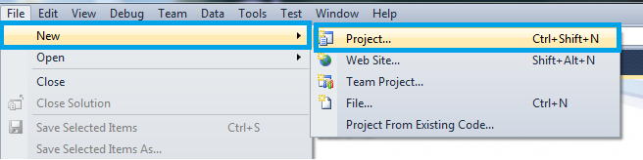  
  
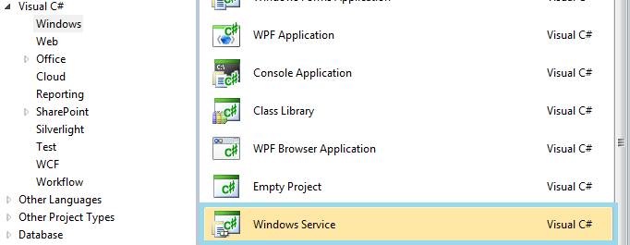  
  
After creating the project you can see the service design page as in the following and click on the link “click here to switch to code view”.  
  
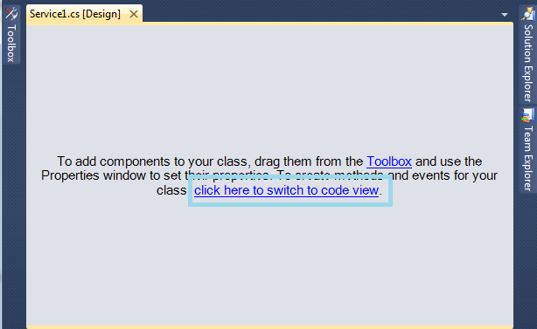  
  
The Solution Explorer will then look like this:  
  
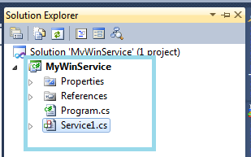  
  
The WinService class should contain the two functions OnStart() and OnStop() and contain the following code:

1. **public** partial **class** WinService : ServiceBase
2. {
3. **public** WinService()
4. {
5. InitializeComponent();
6. }
7. **protected** **override** **void** OnStart(**string**[] args)
8. {
9. //
10. }
11. **protected** **override** **void** OnStop()
12. {
13. //
14. }
15. }

Go to Solution Explorer and right-click on WinService.cs then go to the view designer then look at the design view then right-click on the design page and click on “add installer” and it will look like this:  
  
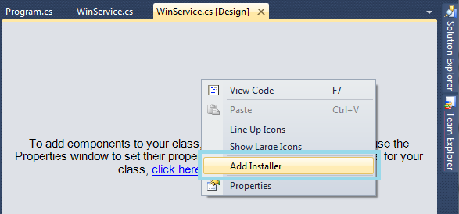  
  
After adding the ProjectInstaller.cs you have 2 components in the design view of the ProjectInstaller.cs (serviceProcessInstaller1 and serviceInstaller1). You should then set up the properties as you need.  
  
Click on serviceinstaller1 and go to the properties in the right pane and edit the service name Service1 to WinService as in the following:  
  
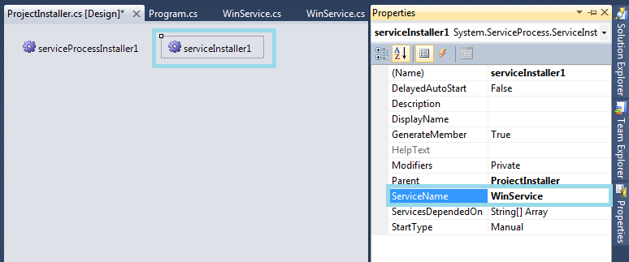  
  
Click on serviceProcessInstaller1 and go to the properties in the right pane and select Account and choose LocalService from the dropdown and save. See the following:  
  
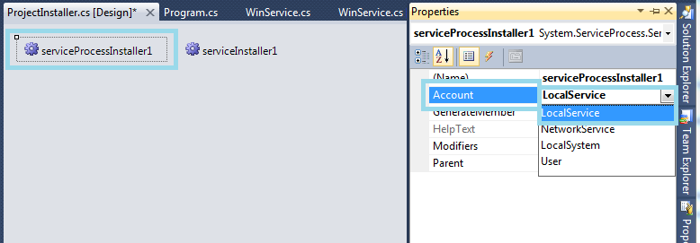  
  
You have two assemblies under References as in the following highlighted (1) System.Configuration.Install and (2) System.ServiceProcess.  
  
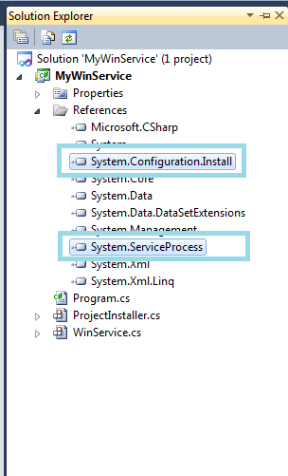  
  
**Create Setup Project**  
  
Build your service project, you need to set up the project to install the build/compiled project and run the installers to run the Windows service. Create a new project as a “Setup Project” and you need to add project output.  
  
**Create Setup Project for Window Service**  
  
Go to the Solution Explorer and right-click on the solution, go to Add > New Project.  
  
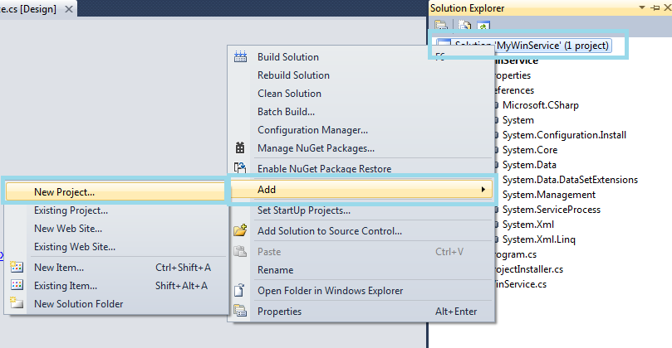  
  
Open a dialog box, go to left pane under Installed Templates > Other Project Types > Setup and Deployment > Visual Studio Installer and go to the right pane and select the project as a “Setup Project” and click on the OK button.  
  
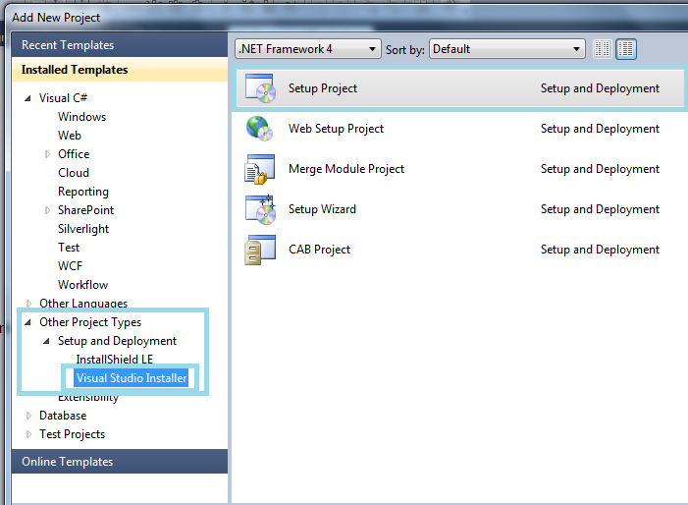  
  
**Custom actions add to setup project**  
Go to the solution, right-click on the setup project then select View > Custom action.  
  
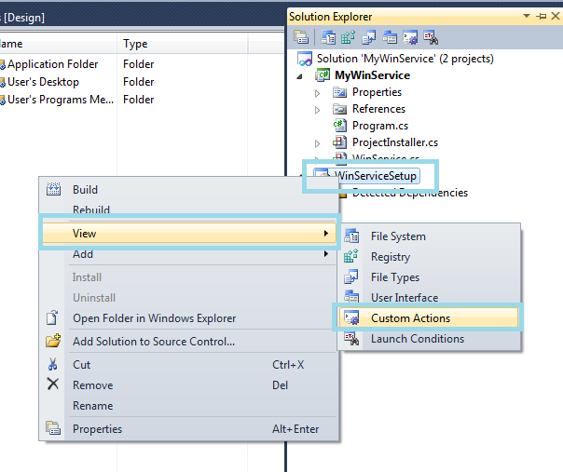  
  
The “Custom action” editor appears.  
  
Right-click on “Custom action > Add Custom action”.  
  
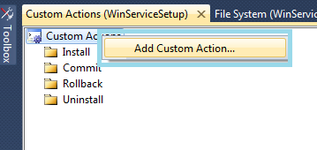  
  
Open a dialog box “Select Item In Project” then double-click on “Application Folder” then click on the “Add Output” button. Open a dialog box, choose your project (Window service) and “Primary Output” from (Active) and click on the OK button.  
  
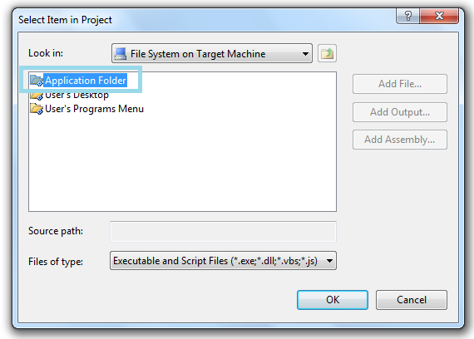  
  
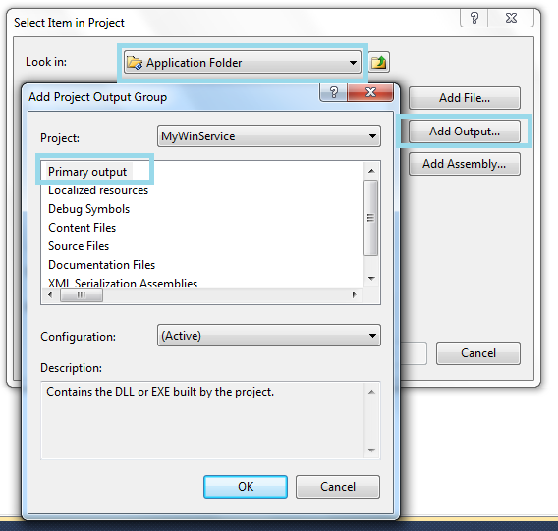  
  
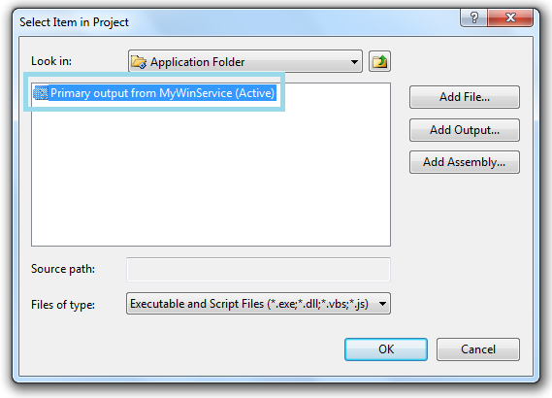  
  
Build your setup project and install the Windows service.